Spark Streaming Optimization

一. Condition One(Video Spark)
1. Version and Context
Spark version is 1.6.1 and Kafka Receiver mode
2. the optimization for Streaming
2.1 basic principle
the count of Receiver is larger than the count of instances.
The count of Receiver * the threads count == the partitions of kafka
the partition numbers is equal to the biggest count of the Events
2.2 the Items for optimization
Item | principle
Window size | The average times of processing time for batch count
Partition numbers | The max events count or half of the max events
Receiver count | The Receiver count is twice count of instances
Threads count | The total partitions of kafka divide the Receiver count

Eg:
1) the selection for window size(6s is the best selection mode)
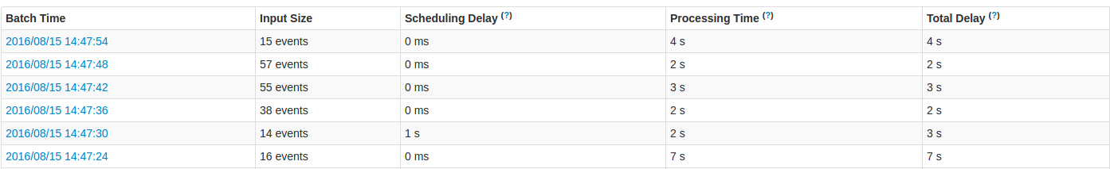
2) the partitions for the repartitions(120 partition number is the best selection mode)

二、Parameters for optimization
Model Name | Parameter Name | Parameter Value
Driver
Executor | spark.streaming.concurrentJobs | jobExecutor 的线程池大小，就是能够并行执行的 Job 数.
Yarn-Scheduler
Serializer

- Executor: Spark.streaming.cocurrentJobs(Spark JobServer如何设定)
jobExecutor 的线程池大小，就是能够并行执行的 Job 数。而DStreamGraph.generateJobs(time) 过程，一次 batch 产生一个 Seq[Job}，里面可能包含多个 Job —— 所以，确切的，*有几个 *output 操作，就调用几次 ForEachDStream.generatorJob(time)，就产生出几个 Job **。
为了验证这个结果，我们做一个简单的小测试：先设置 spark.streaming.concurrentJobs = 10，然后在每个 batch 里做2 次 foreachRDD() 这样的 output 操作：
// 完整代码可见本文最后的附录
val BLOCK_INTERVAL = 1 // in seconds
val BATCH_INTERVAL = 5 // in seconds
val CURRENT_JOBS = 10
...

// DStream DAG 定义开始
val inputStream = ssc.receiverStream(...)
inputStream.foreachRDD(_ => Thread.sleep(Int.MaxValue)) // output 1
inputStream.foreachRDD(_ => Thread.sleep(Int.MaxValue)) // output 2
// DStream DAG 定义结束
...
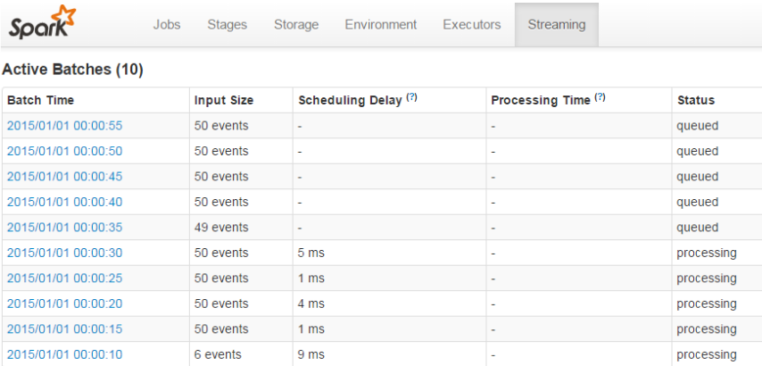
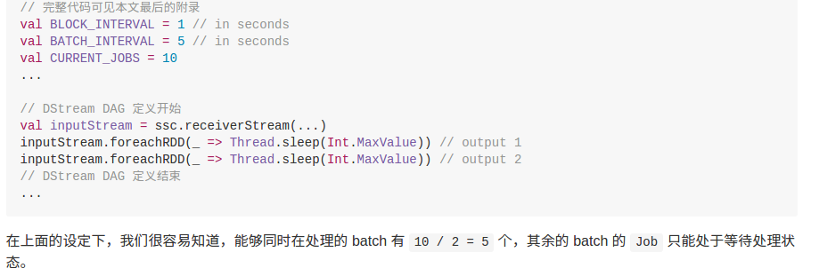
在上面的设定下，我们很容易知道，能够同时在处理的 batch 有 10 / 2 = 5 个，其余的 batch 的 Job 只能处于等待处理状态。
- others

